Blog post

The scalability feature is significant to the Bitcoin, and the cheap costs of transactions are what motivates users to build a network of channels. Either for profit or convenience, a user might provide a service for intermediate transactions. Thus, we investigate the fee bound of lightning network indirect transactions through simulating the network of 3 or 4 nodes with structures such as a star, cycle, or line, with simulations and theoretical calculations.

We made a simulated model of the lighting network, which consists of nodes, channels, and payments (direct or transferred), while the online transaction cost and time spent are constant. The capacities of the channels are automatically optimized based on their payments, and their costs are updated whenever they require updates.

Based on different structures of the network, we compare the cost of the users. With the lowest cost and the highest cost, the fee bound of intermediate nodes is computed. Note that in this report, we refer to the amount of time between each transaction as frequency.

# Three Node Network

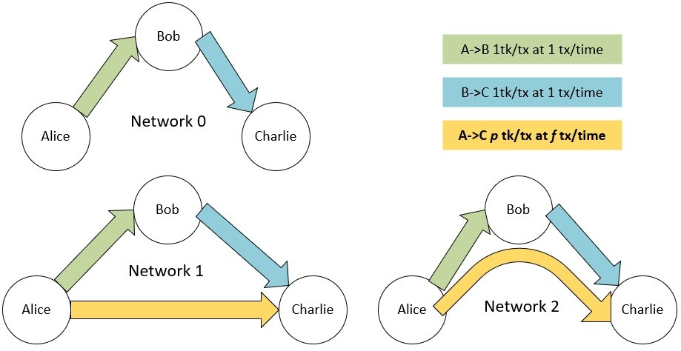

Figure . Network 0: only two direct transfers. Alice will be making extra transactions on-chain. Network 1: Alice creates a direct channel with Charlie on LN. Network 2: Alice sends indirect payments through Bob to Charlie

When Alice wants to pay Charlie, who she is not directly connected to, Alice has the option to make on-chain payments, build a direct channel with Charlie, or route the payment through Bob. In order to define how the costs of the channels were split between the two nodes, we first assume that in setup 0 and in setup 1, each node pays half of the total cost of their shared channels. Then, for setup 2, we assume that Bob is willing to provide a service, such that if Bob transfers for Alice, Bob will pay the total additional costs of the channel and charges a fee towards Alice.

As we compare Alice’s costs between her three options, the transaction fee must be less than the cost of her creating her own channels in order for her to use Bob as a service, thus, the maximum bound is a1-a0. For Bob, his profit is the difference between the change of cost of channel maintenance and the transaction fee. Thus, the minimum fee is bounded by the change of cost of channels, which is calculated by b2+a2-a0-b0. This setup allows us to calculate the benefit of doing an indirect transaction instead of creating a direct channel for all three parties.

## Fee bounds with respect to payment size

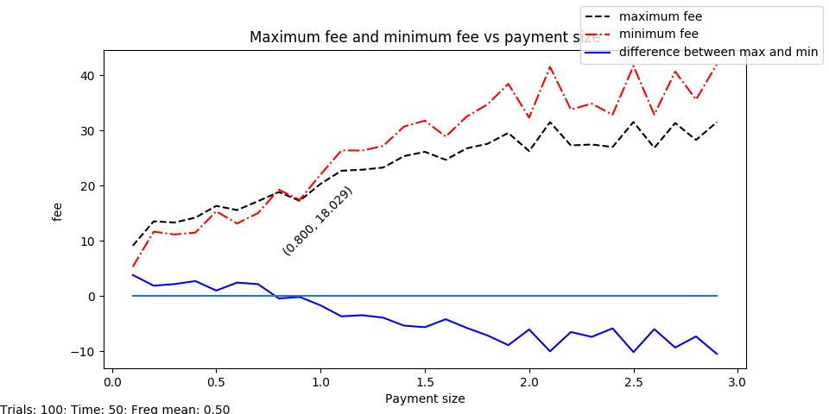

Figure . As the payment size increase, the maximum fee and the minimum fee increases at different rates. They intersect at payment size = 0.8

With a frequency mean of 0.5, we find that, shown by figure 3, as the payment size increase, the maximum fee and the minimum fee increases at different rates. Up-to a certain payment size, two parties can find a fee within the fee bounds that are mutually beneficial. However, after that, Bob must require more fees to cover the difference in channel costs than Alice is incentivized to pay. As demonstrated by the difference between max and min line, the fee bounds are feasible when the differences are positive, and infeasible when the differences are strictly negative. This also means that in order for Bob to lower his fees, he needs other incentives such as to balance the channel capacities.

## Fee bounds with respect to the number of payments within 1 time period

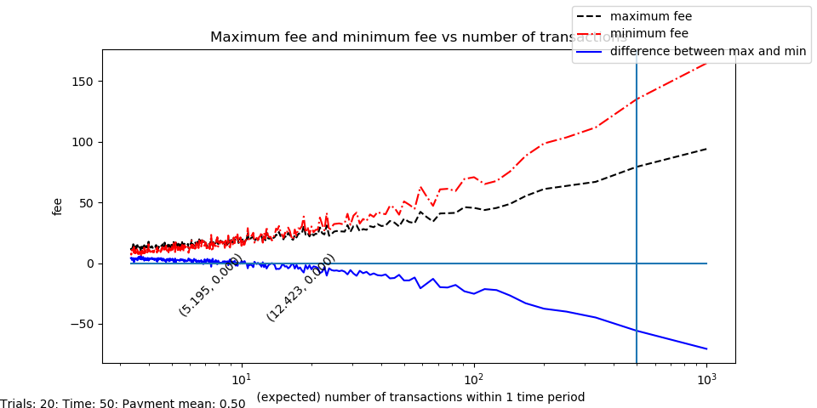

Figure . As the expected number of transactions within a time unit increases, when the maximum fee is greater than the minimum fee, it is more optimal to use the indirect channel. When the maximum fee is less than the minimum fee, and the number of transactions is less than the vertical line

The explanation for figure 4 is, with payment size mean being 0.5, we find that an agreement to the fee can be reached if the expected number of transactions within in time unit is 5. (lambda = 0.2). As lambda decreases and the expected number of transactions increases, both the maximum fee and the minimum fee increases at different rates, such that the two parties cannot find a mutually beneficial fee if the number of transactions exceeds 5.

Also, note that the vertical line indicates the minimum lambda or maximum expected number of transactions for when Alice would prefer to make transactions outside of lightning. We calculated this line based on Lemma 0.1 from Clara's document "Asymptotic for Lightning Network" section 0.7. The interval between the vertical line and the intersection is the range of frequency that Alice would prefer to create a direct channel with Charlie instead of using indirect transfers or make on-chain transactions.

With respect to size and frequency

To find the possible fees, we find the intersection of frequency and intersection points between maximum and minimum fee, since a positive difference means that there exist a feasible fee bound, and a strictly negative difference means that there does not exist a feasible fee bound.

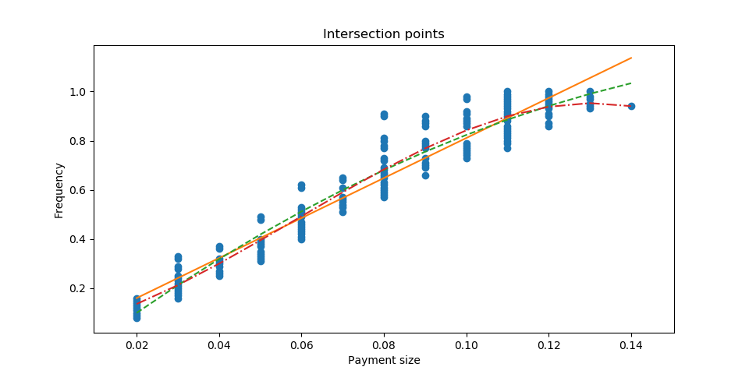

Figure . For all the points, the maximum fee equates to a minimum fee. The best fit line of order 1, 2, and 3 attempts to learn their relationship.

Figure 7 shows the intercepts of the differences. Based on these points, we are able to locate the exact point at which larger payments or more frequent transactions become infeasible. This graph shows a more direct relationship between frequency and payment. A smaller payment will allow more indirect payments to route through the intermediate node during a time unit.

## With Other Setups

We repeated the same steps of simulation on setup 1 and 2. The simulation results suggest that a higher amount of payments and larger size of payments causes maximum fee to decrease and minimum fee to increase, leading to smaller or even infeasible fee bound. However, once payment sizes are small enough or the frequency is large enough, indirect transfers are encouraged instead of building direct channels if we only look at channel costs. While we are looking at the three-node structure, we are overlooking many other factors, such as the value of a centralized node, incentive to balance channel capacities, inconsistent payments, etc. Despite the overlooked extra specifications, the model shows clear criteria for the fee bound feasibility based on payment size and frequency.

When comparing two types of setups of the same network, we find that if the indirect payment goes against the direction of some payments on the route of transfers, the feasible interval of the differences is larger. We can explain this change as if Bob is further incentivized to serve as an intermediate node for rebalancing the channels. If the payments are going against the direction of Bob's regular payments, Bob may update his channels less often, thus decreasing the cost to maintain the channel. When the payments are significant enough, Bob might be incentivized to pay Alice for such indirect transfers. Naturally, we further investigate the possibility of a negative minimum fee.

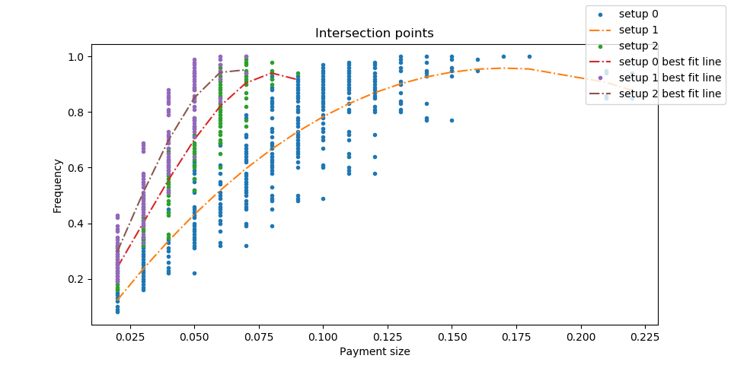

Comparing the three intersection point graphs, we have shown that setup 2 has the deepest slope, thus allowing more combinations of payments to go through. However, due to the dip at the end, we increase the range of the payments and frequency to find the behavior of intersection points for all three setups.

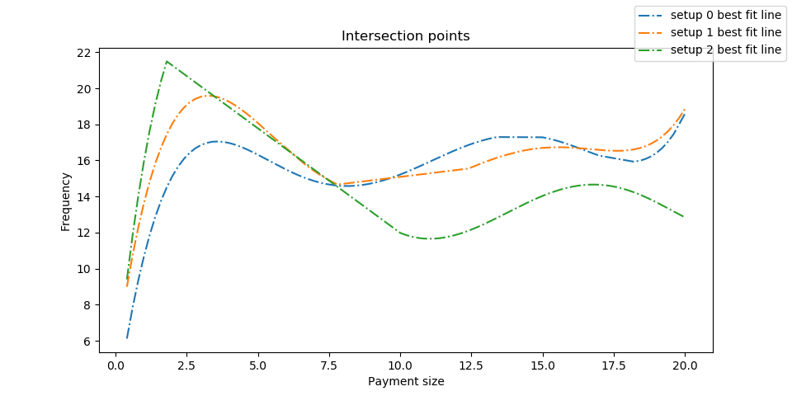

It is interesting to see that setup 2 eventually becomes the least incentivizing setup after the payment size grows above 1. This could be explained by the increase in the cost of bidirectional channels. While setup 0 only has unidirectional channels, setup 2 becomes more expensive to maintain as the channel sizes are increased significantly.

# Conclusion

By running simulations, we find that smaller payments or less frequent payments are encouraged to be traded indirectly. The intersection plots show that each payment or frequency requirement provides abound towards the other, in order to make indirect transactions.

There is a lot of possibility for further investigation, such as observing the intersection points' behavior near 0 of size or frequency, the possibility of a negative minimum fee, reduction of larger networks to three-node networks, build transaction fee based on single payments, and of each intermediate node instead of the total fee.